**Pavement Preservation Guide Documentation**

**Folder structure**

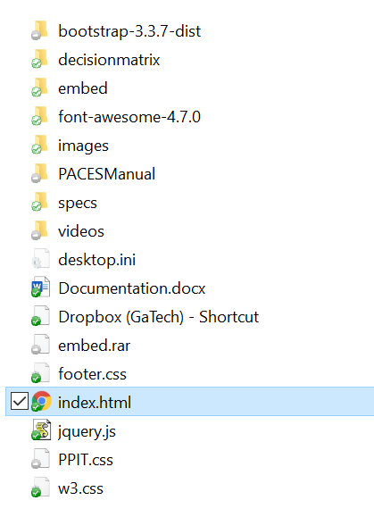

*Bootstrap-3.3.7-dist*

* CSS files that construct the pattern and structure of the website

*Decisionmatrix*

* The original decision matrix provided by GDOT to show the appropriate method for each distress.

embed

* all the pages except index.

*Font-awesome-4.7.0*

* CSS files that construct the pattern and structure of the website

*images*

* all the images needed on the web site

*PACESManual*

* Original files and images. Just used as backup.

*specs*

* all the pdf files of papers. There are some pages that have the links to them

*videos*

* all the videos needed on the web site

*index.html*

* the main page of the web site, from this page, you can link to all the information you want, so open this page first

**Website structure**

Home page

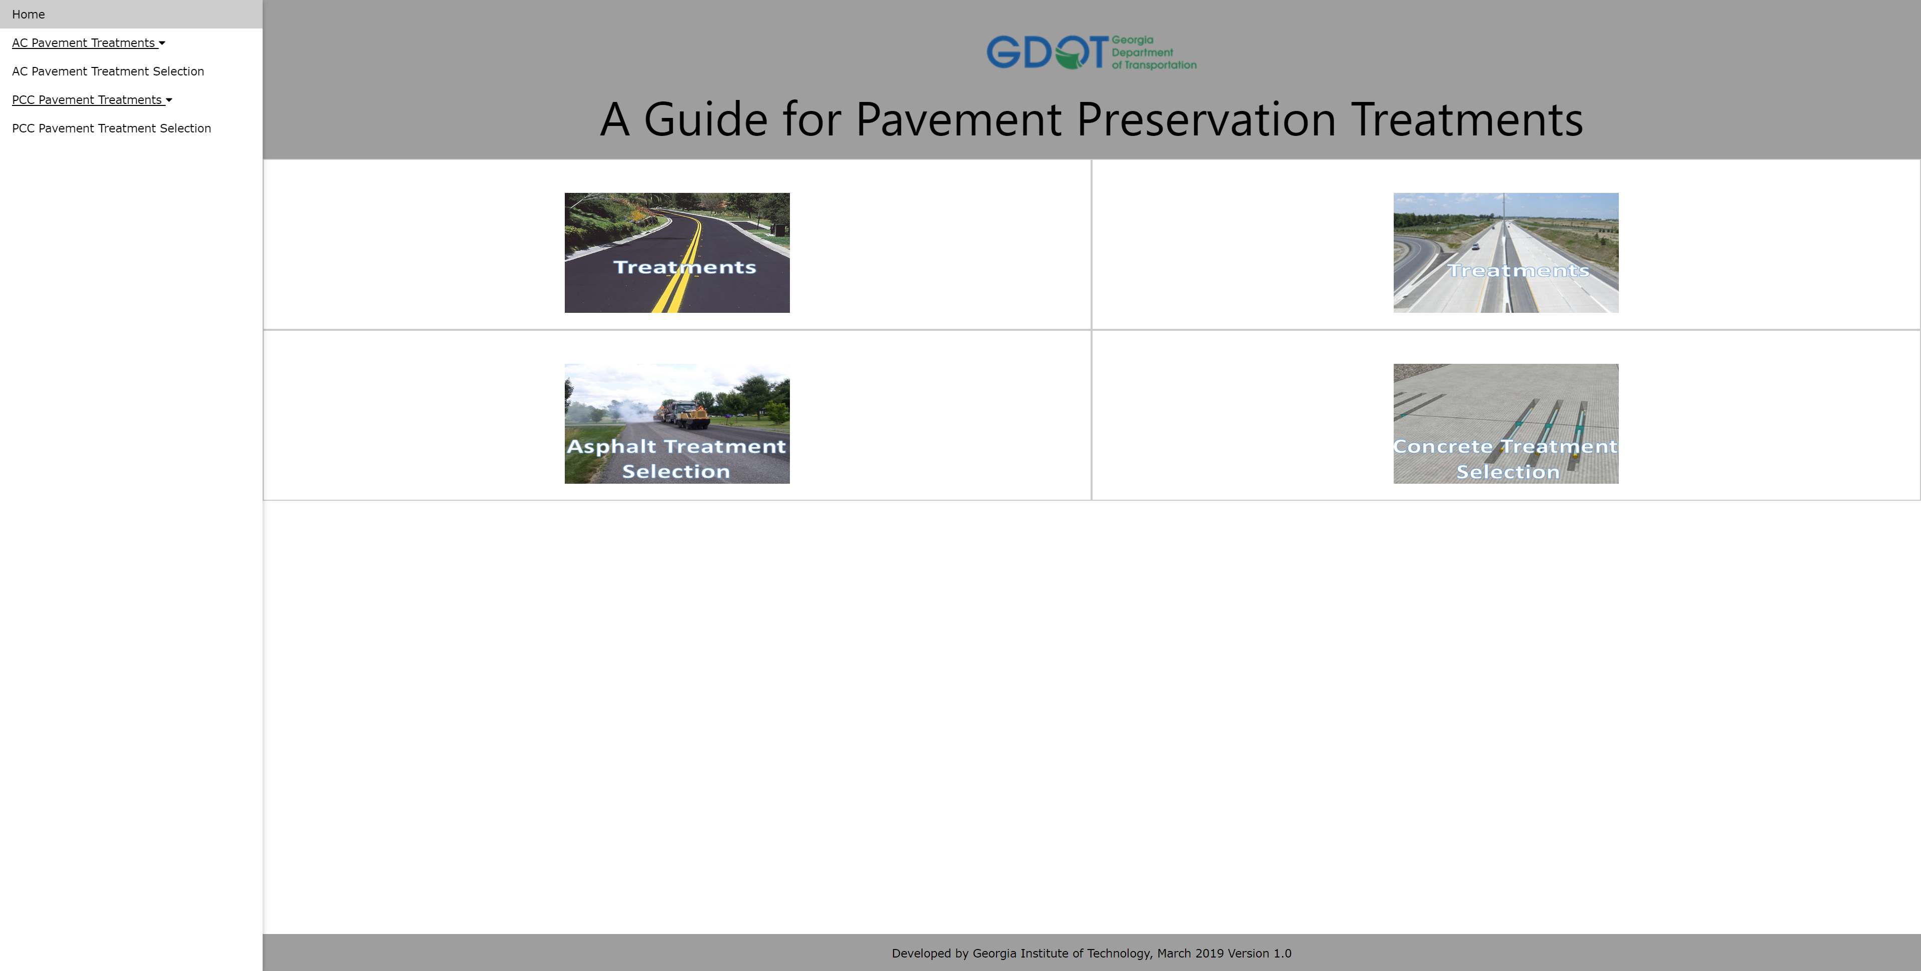

Side navigation bar

Copyright

Image navigation

Title

Content page

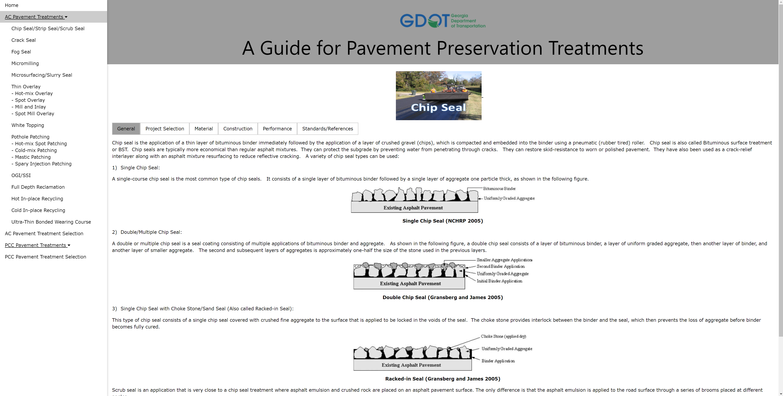

Extended Side navigation bar

Main content

Content navigation tag

Click this image will return to “General” page

Introduction of content page

*General*

* The overview of this pavement preservation treatments method

*Project* selection

* Introduction of how to decide the candidates for this method. May provide some image to show the good and poor candidates.

*Material*

* Material used for this treatment method

*Construction*

* Introduction of the construction procedures. May provide videos

*Performance*

* Performance of this treatment method on different distress

*Standards\references*

* Including the link to pdf file of GDOT specifications, the details of materials and the references

AC Pavement selection page

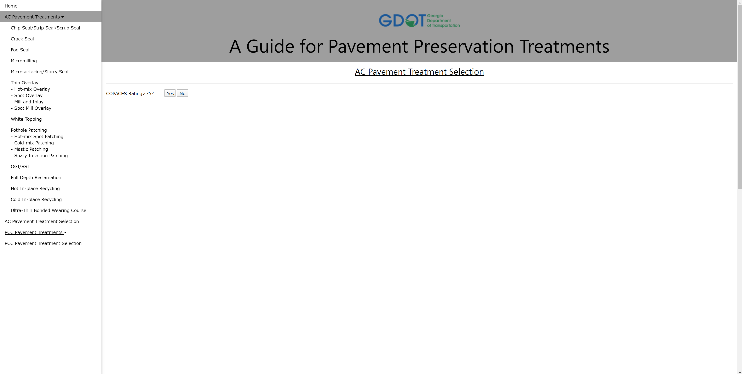

Users need to choose if the COPACES Rating is larger than 75 at first

Click this link will open original PDF file of selection matrix

Click “AC Pavement Treatment Selection” will go to this page

If User choose no, which means the COPACES Rating is less than 75, then we will say “No Preservation Recommended”. Because GDOT consider the pavement that has COPACES Rating less than 75 need to be resurfaced instead of doing treatment.

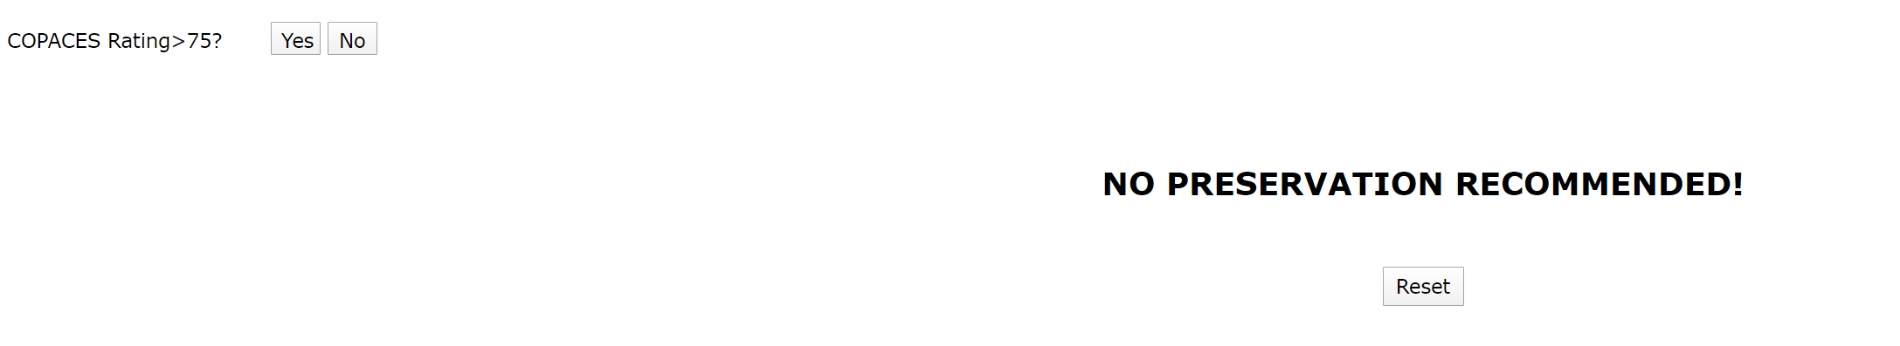

If user choose yes, which means the COPACES Rating is larger than 75, we will give the distress and severity level choosing boxes.

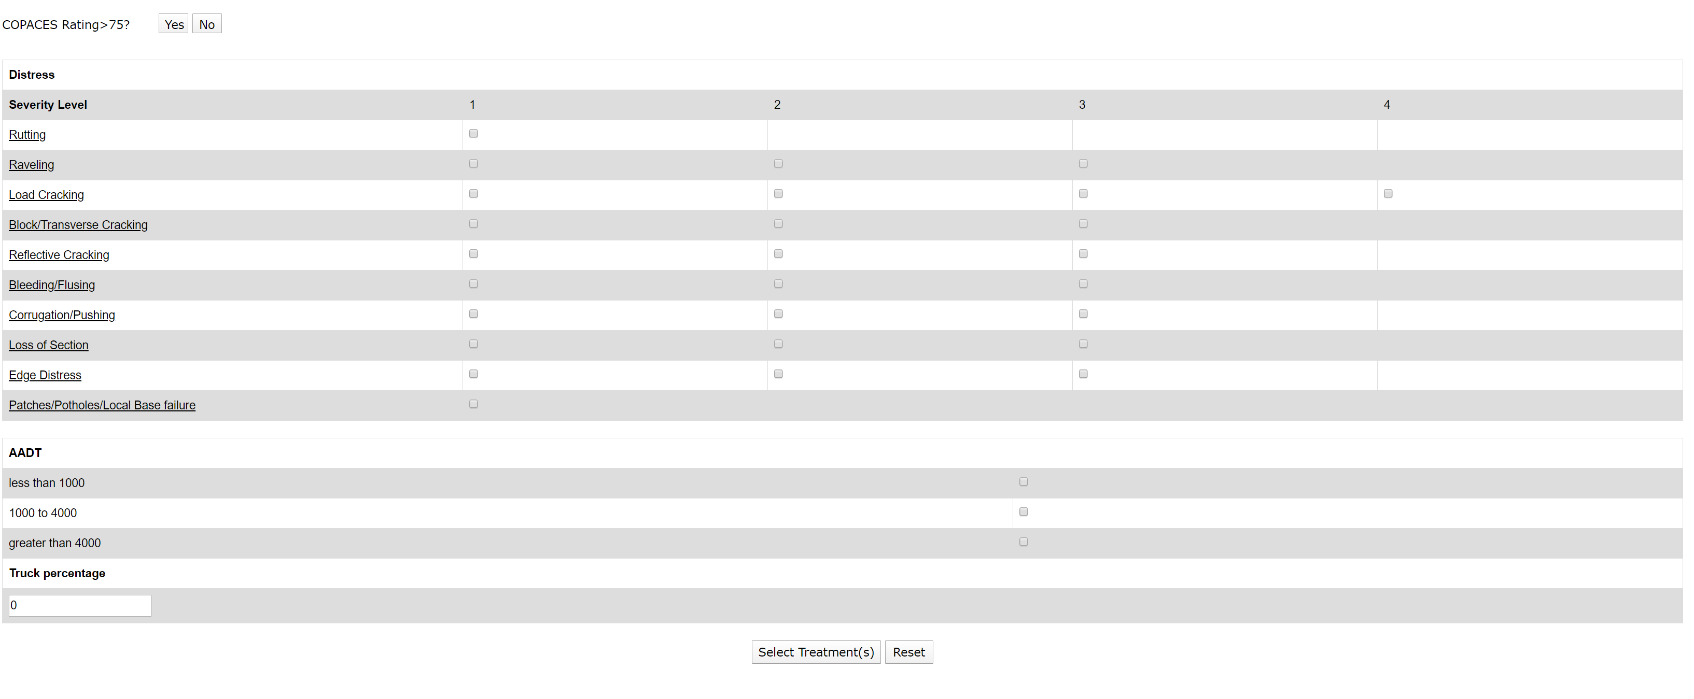

Distress and severity level choosing page

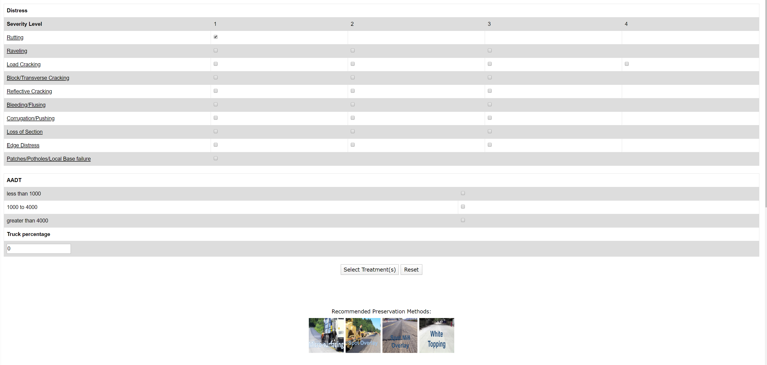

If there are appropriate treatment methods, the images with links will showing here. User could click the images to go to the introduction pages

Severity level choosing boxes

Distresses. Click the link will lead to the pages that introduce how to determine the severity level

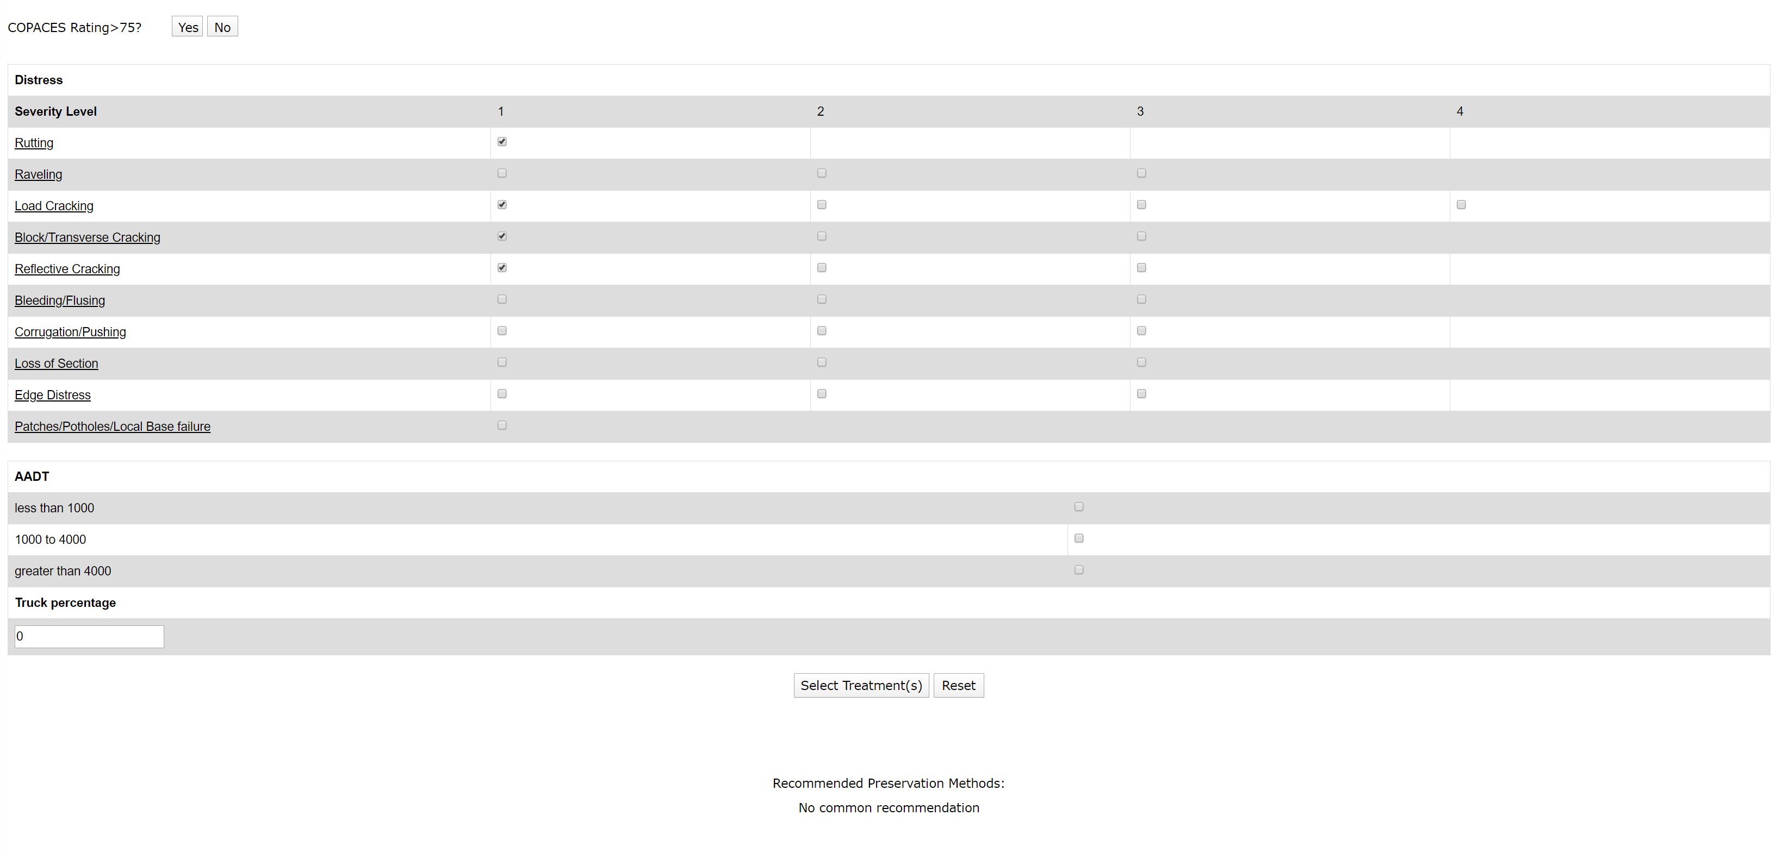

If there are no appropriate treatment methods, we will show “no common recommendation” here

PCC pavement treatment selection page

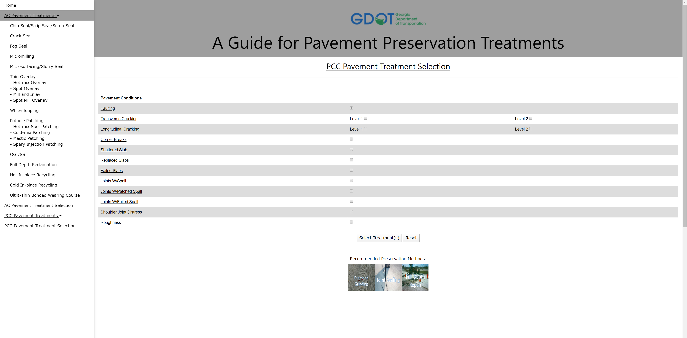

Click “PCC Pavement Treatment Selection” will go to this page. Same structure as “AC Pavement Treatment Selection”

**Introduction of code**

*For index page*

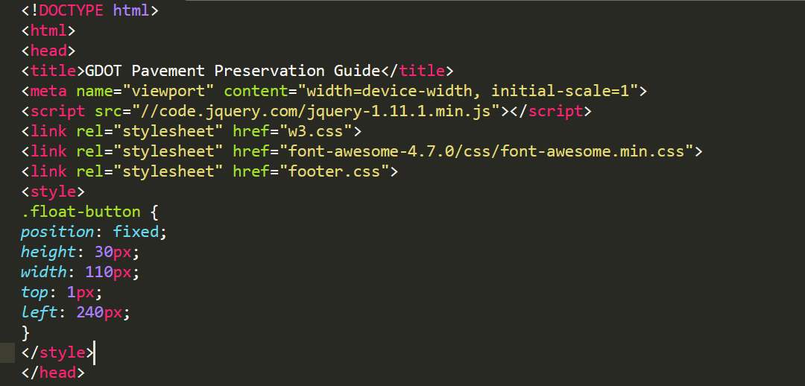

Code holding the style of website. If need to change the style, change the content in CSS files.

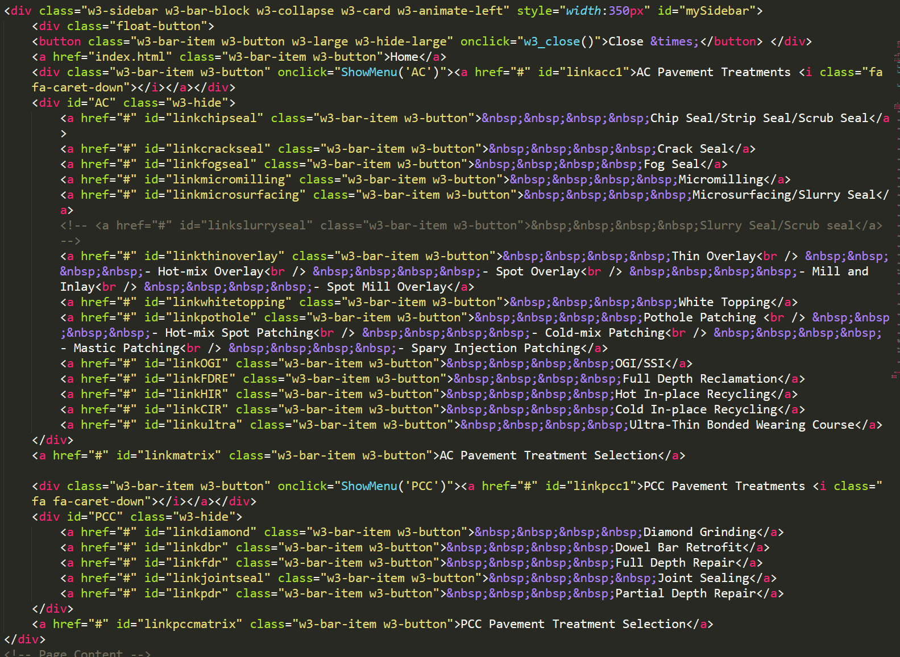

Code of side navigation bars

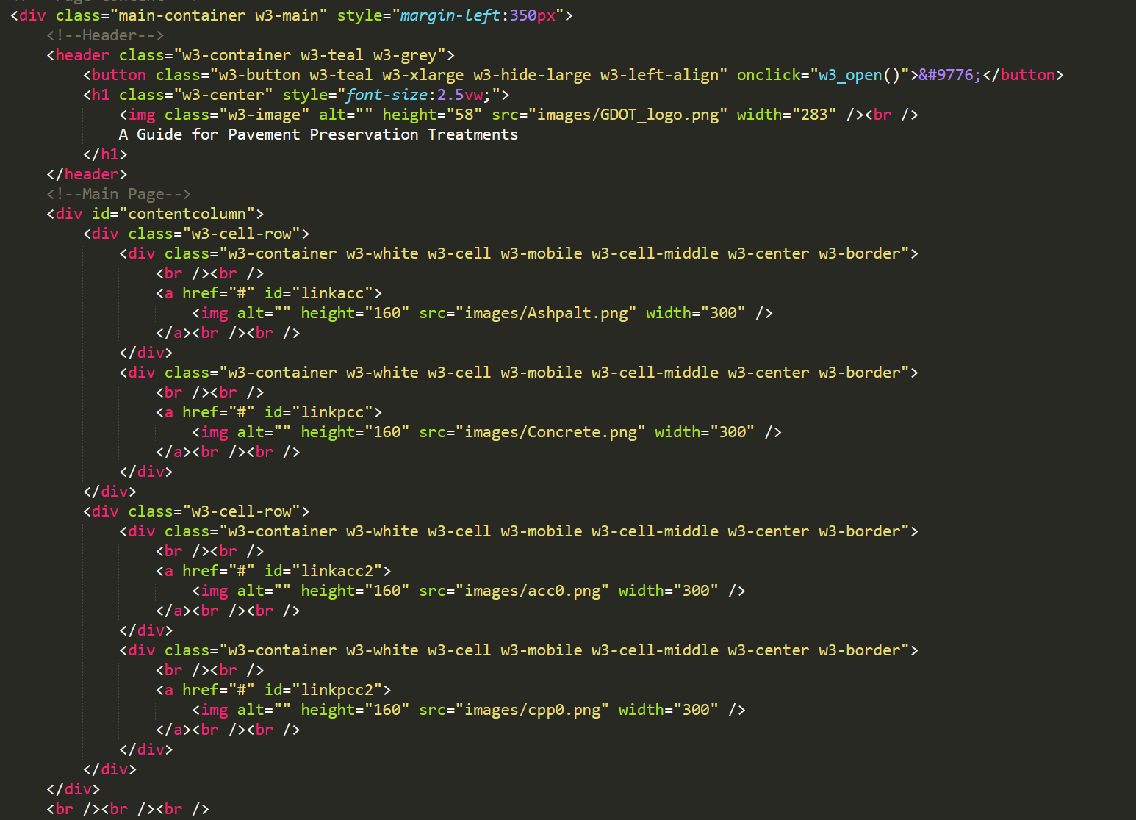

Code of main content with image navigation

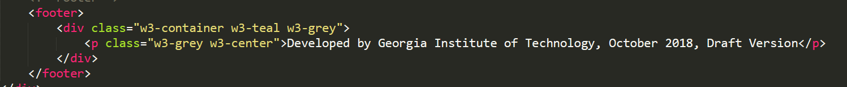Code of footer (copyright)

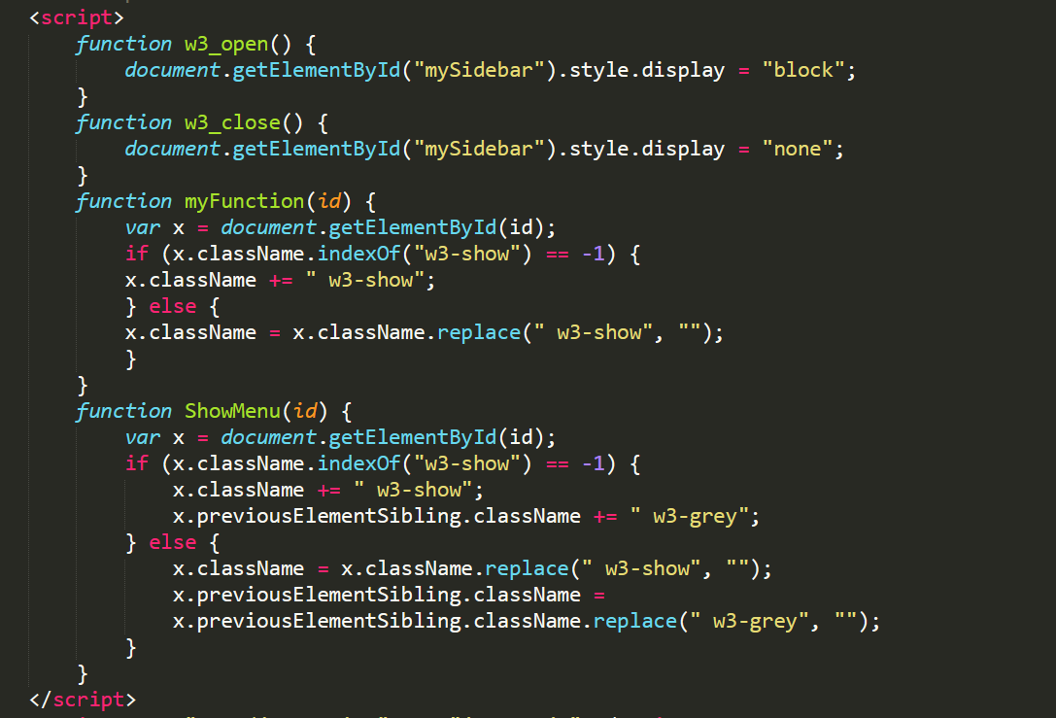

This code helps to hide the side bar if the screen is small. When you open the website on the mobile phone, the side navigation bar will hide automatically. But there will be a green button on the left-upper corner. The side navigation bar will be shown when you click the button.

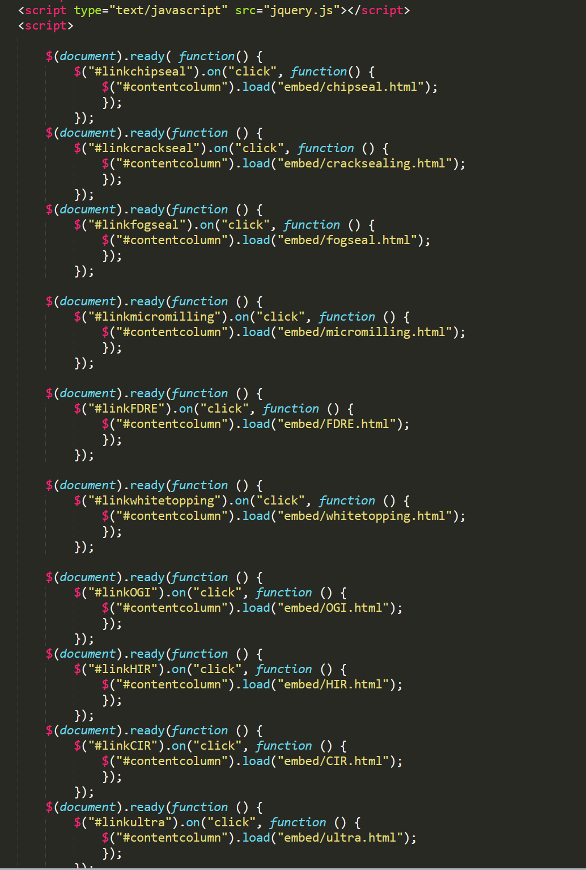

Since all the pages on this website will have the same layout. If we put the layout code on every page, we need to change the code on every page if we want to change the layout later. However, this jquery function helps to open each page on just the content div. By doing this, the side navigation bar, title and footer parts will not change when open the new page. As a result, we only need to change the layout code on the index page and the layout of all the pages will change. The function is

$(document).ready(function () {

$("#idOfTheLink").on("click", function () {

$("#contentcolumn").load("embed/destinationPageLink");

});

});

Each new page needs to have its own function.

*Content page*

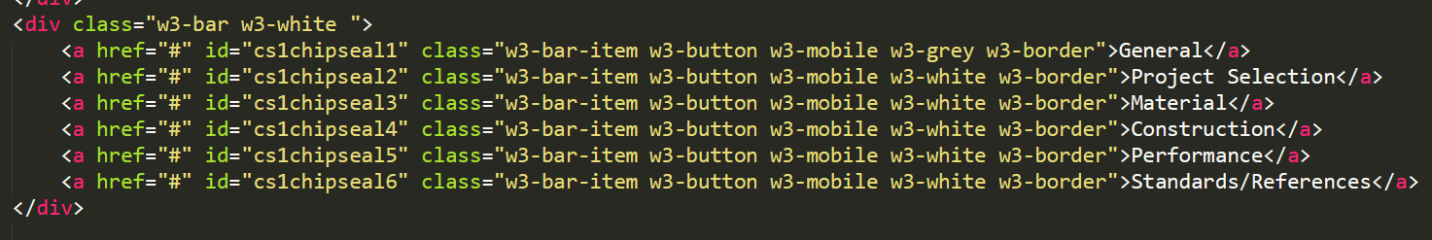

Code of content navigation tag

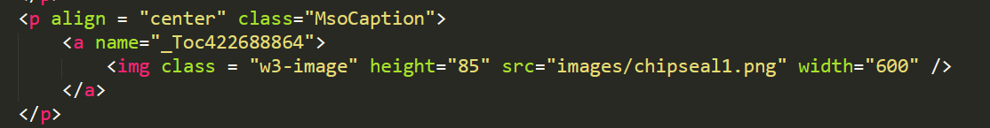

Code of images. This code could help the image change the size according to the page size. “width” and “height” help to set the original size when the page is big enough.

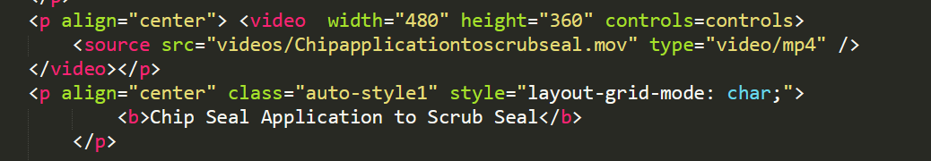

Code of videos. Video could also change the size according to the page size.

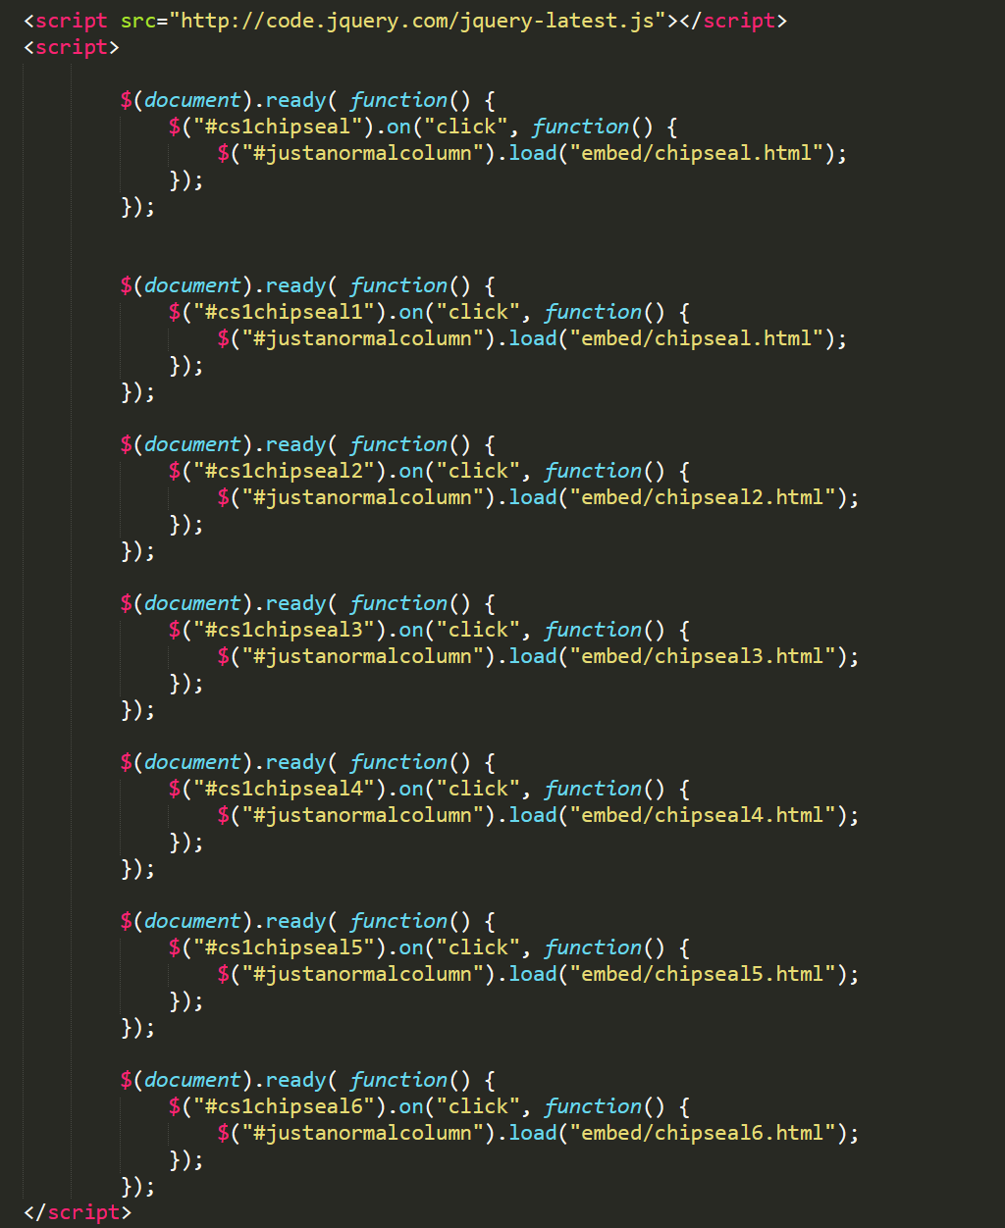

Jquery code to open the new page in content column.

Be careful that the name of contentcolumn here is “justanormalcolumn”

*AC and PCC pavement treatment page*

Main logic code of AC pavement treatment selection in “matrix_embedded.html” and main logic code of PCC pavement treatment selection in “pccmatrix_embedded.html”. The logic is hard coding based on the decision matrix table provided by GDOT. The common treatment method for the distress type chosen by user will show.

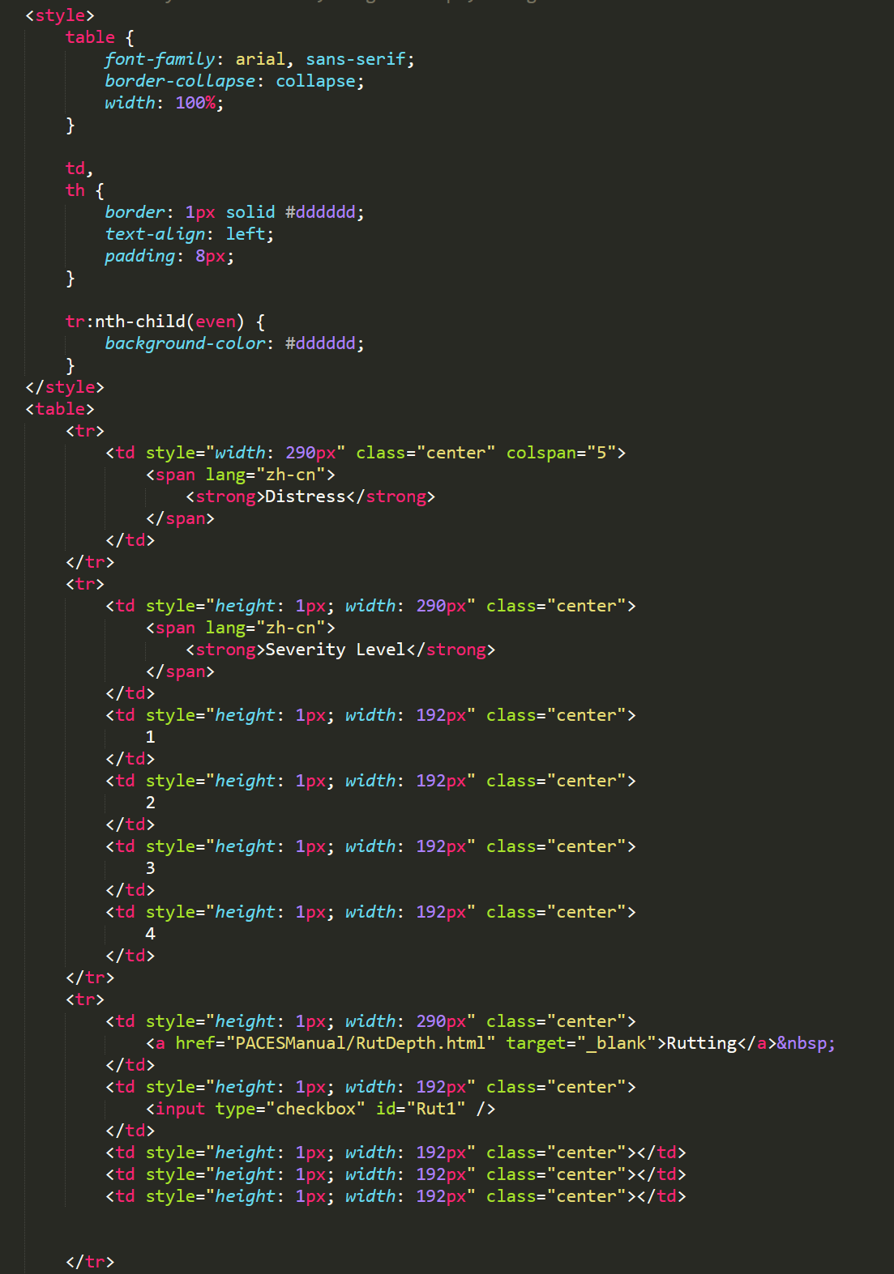

Table and style of the selection matrix.

“colspan” is number of columns in this row

the content for a row put in a pair of <tr></tr> tag

the content for a cell put in a pair of <td></td> tag

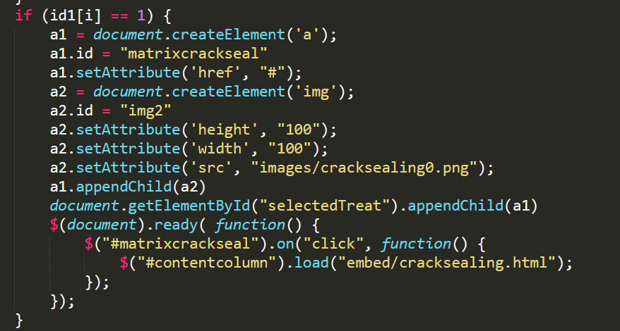

Each treatment method has one paragraph of code like this. This help to set the image and the link of the content page. The jquery script is also included to open new page only on the content column.

**Other comment**

If wants to open the website locally on Chrome and wants to have all the functions works correctly, need to do the following. However, if you want to open locally on Firefox, you don’t need to do this.

1: Launch “Command Prompt” on window system

2: Enter “ "(Path of chrome program)\chrome.exe" --allow-file-access-from-files ” in Command Prompt to open Chrome and let it allow file access from files.

Use my path of chrome as example. I should enter

"C:\Program Files (x86)\Google\Chrome\Application\chrome.exe" --allow-file-access-from-files

3: Open “index.html” file and operate the web site

*Why doing this*

I use jQuery algorithm to realize that when you want to open another page, the content will load into the contentcolumn instead of going to a new page. By this way, you don’t need to change code of every page if you want to change the layout of the web site. You only need to change the code of “home” page. JQuery algorithm is loaded from online. So, if you don’t open chrome as I said before or your laptop is not connecting to internet, this function will not run correctly. However, when the whole web site runs on the web server, this function will run properly.

**If need to improve the website**

1: If need to change the content of method introduction, just change the code of embedded pages, do not change the index page.

2: If need to change the decision matrix, hard code the logic to change the recommendation result. But all the method links are already there, you don’t need to change them.

3: If need to change the style of the website. Change the code in CSS file the control the character size, style and front.

4: If need to change the layout of the website. Change the code in “index.html”. But remember always keep a contentcolumn for the opening of embedded pages.